**Data Aggregation Activity**

**Table of Contents**

Section 1: Queries Used 2

***1.1 Loading the “employee” Table 2***

***1.2 Data Transformation Steps 3***

***1.3 Data Aggregation Steps 3***

Count of Employees with Attrition 3

Count of Employees without Attrition 4

Income Statistics for All Employees 4

Income Statistics for Employees with Attrition 4

Income Statistics for Employees without Attrition 5

Count by Monthly Income for Salespeople with Attrition 5

Count by Monthly Income for Salespeople without Attrition 6

Section 2: Screenshots 7

***2.1 Verifying Data Transformation Steps 7***

***2.2 Data Aggregation Steps 8***

Count of Employees with Attrition 8

Count of Employees without Attrition 9

Income Statistics for All Employees 10

Income Statistics for Employees with Attrition 11

Income Statistics for Employees without Attrition 12

Count by Monthly Income for Salespeople with Attrition 13

Count by Monthly Income for Salespeople without Attrition 14

# Section 1: Queries Used

## 1.1 Loading the “employee” Table

CREATE EXTERNAL TABLE employee

(

Age int,

Attrition string,

BusinessTravel string,

DailyRate int,

Department string,

DistanceFromHome int,

Education int,

EducationField string,

EmployeeCount int,

EmployeeNumber int,

EnvironmentSatisfaction int,

Gender string,

HourlyRate int,

JobInvolvement int,

JobLevel int,

JobRole string,

JobSatisfaction int,

MaritalStatus string,

MonthlyIncome int,

MonthlyRate int,

NumCompaniesWorked int,

Over18 string,

OverTime string,

PercentSalaryHike int,

PerformanceRating int,

RelationshipSatisfaction int,

StandardHours int,

StockOptionLevel int,

TotalWorkingYears int,

TrainingTimesLastYear int,

WorkLifeBalance int,

YearsAtCompany int,

YearsInCurrentRole int,

YearsSinceLastPromotion int,

YearsWithCurrManager int

)

ROW FORMAT DELIMITED FIELDS TERMINATED BY ','

LINES TERMINATED BY '\n'

STORED AS TEXTFILE LOCATION '/Employee'

TBLPROPERTIES("skip.header.line.count"="1");

## 1.2 Data Transformation Steps

CREATE EXTERNAL TABLE employee_sales

(

Attrition string,

Department string,

JobSatisfaction int,

MonthlyIncome int

);

INSERT OVERWRITE TABLE employee_sales

SELECT Attrition, Department, JobSatisfaction, MonthlyIncome

FROM employee;

INSERT OVERWRITE TABLE employee_sales

SELECT Attrition, Department, JobSatisfaction, ROUND(MonthlyIncome, -3) as MonthlyIncome

FROM employee_sales;

INSERT OVERWRITE TABLE employee_sales

SELECT *

FROM employee_sales

WHERE Department LIKE "%Sales%";

INSERT OVERWRITE TABLE employee_sales

SELECT *

FROM employee_sales

ORDER BY JobSatisfaction DESC;

SELECT * FROM employee_sales LIMIT 20;

## 1.3 Data Aggregation Steps

### Count of Employees with Attrition

CREATE EXTERNAL TABLE employee_attrition

(

attrition int

);

INSERT OVERWRITE TABLE employee_attrition

SELECT COUNT(Attrition) AS attrition

FROM employee_sales

WHERE Attrition LIKE "%Yes%";

SELECT * FROM employee_attrition;

### Count of Employees without Attrition

CREATE EXTERNAL TABLE employee_non_attrition

(

non_attrition int

);

INSERT OVERWRITE TABLE employee_non_attrition

SELECT COUNT(Attrition) AS non_attrition

FROM employee_sales

WHERE Attrition LIKE "%No%";

SELECT * FROM employee_non_attrition;

### Income Statistics for All Employees

CREATE EXTERNAL TABLE all_employee_income_stats

(

average_monthly_income double,

min_monthly_income int,

max_monthly_income int

);

INSERT OVERWRITE TABLE all_employee_income_stats

SELECT AVG(MonthlyIncome) AS average_monthly_income, MIN(MonthlyIncome) AS min_monthly_income, MAX(MonthlyIncome) AS max_monthly_income

FROM employee_sales;

SELECT * FROM all_employee_income_stats;

### Income Statistics for Employees with Attrition

CREATE EXTERNAL TABLE attrition_employee_income_stats

(

average_monthly_income double,

min_monthly_income int,

max_monthly_income int

);

INSERT OVERWRITE TABLE attrition_employee_income_stats

SELECT AVG(MonthlyIncome) AS average_monthly_income, MIN(MonthlyIncome) AS min_monthly_income, MAX(MonthlyIncome) AS max_monthly_income

FROM employee_sales

WHERE Attrition LIKE "%Yes%";

SELECT * FROM attrition_employee_income_stats;

### Income Statistics for Employees without Attrition

CREATE EXTERNAL TABLE non_attrition_employee_income_stats

(

average_monthly_income double,

min_monthly_income int,

max_monthly_income int

);

INSERT OVERWRITE TABLE non_attrition_employee_income_stats

SELECT AVG(MonthlyIncome) AS average_monthly_income, MIN(MonthlyIncome) AS min_monthly_income, MAX(MonthlyIncome) AS max_monthly_income

FROM employee_sales

WHERE Attrition LIKE "%No%";

SELECT * FROM non_attrition_employee_income_stats;

### Count by Monthly Income for Salespeople with Attrition

CREATE EXTERNAL TABLE attrition_income_count

(

monthlyincome int,

count int

);

INSERT OVERWRITE TABLE attrition_income_count

SELECT MonthlyIncome AS monthlyincome, COUNT(MonthlyIncome) AS count

FROM employee_sales

WHERE Attrition LIKE "%Yes%"

GROUP BY monthlyincome;

SELECT * FROM attrition_income_count;

### Count by Monthly Income for Salespeople without Attrition

CREATE EXTERNAL TABLE non_attrition_income_count

(

monthlyincome int,

count int

);

INSERT OVERWRITE TABLE non_attrition_income_count

SELECT MonthlyIncome AS monthlyincome, COUNT(MonthlyIncome) AS count

FROM employee_sales

WHERE Attrition LIKE "%No%"

GROUP BY monthlyincome;

SELECT * FROM non_attrition_income_count;

# Section 2: Screenshots

## 2.1 Verifying Data Transformation Steps

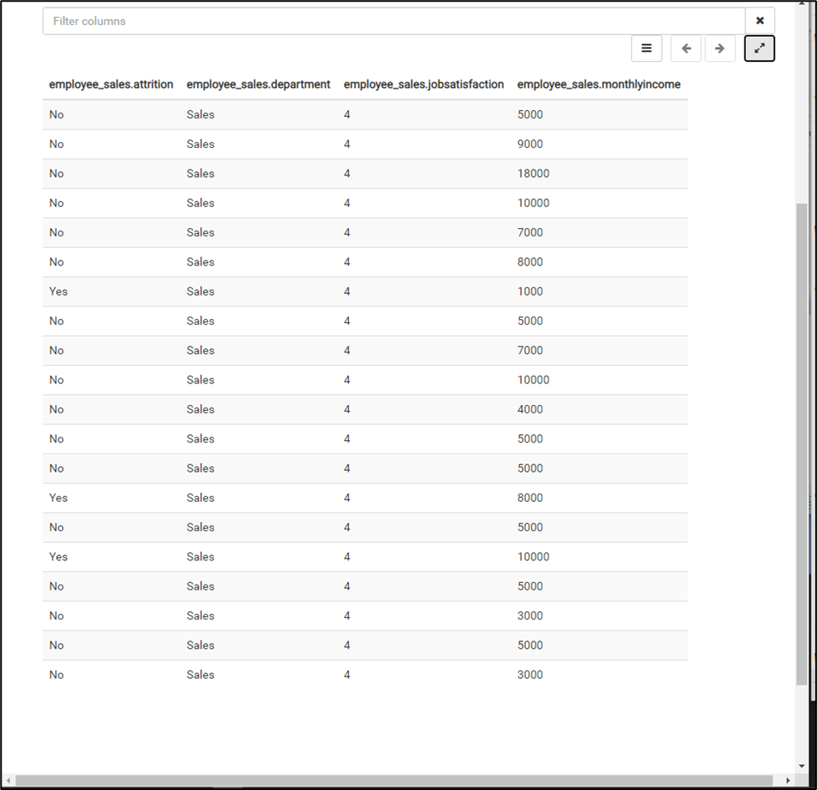

## 2.2 Data Aggregation Steps

### Count of Employees with Attrition

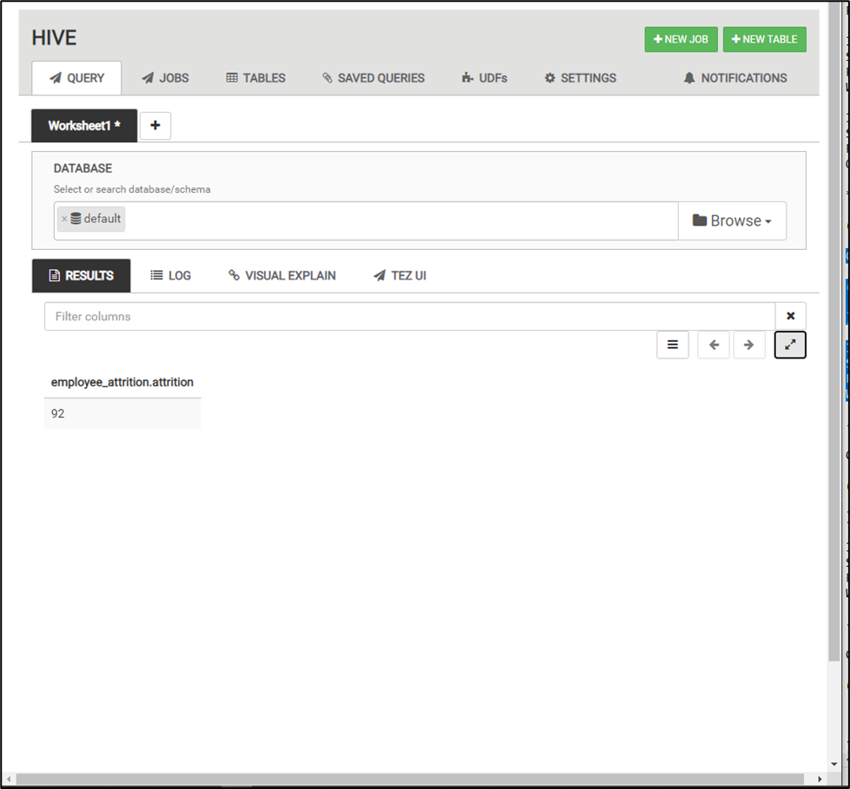

### Count of Employees without Attrition

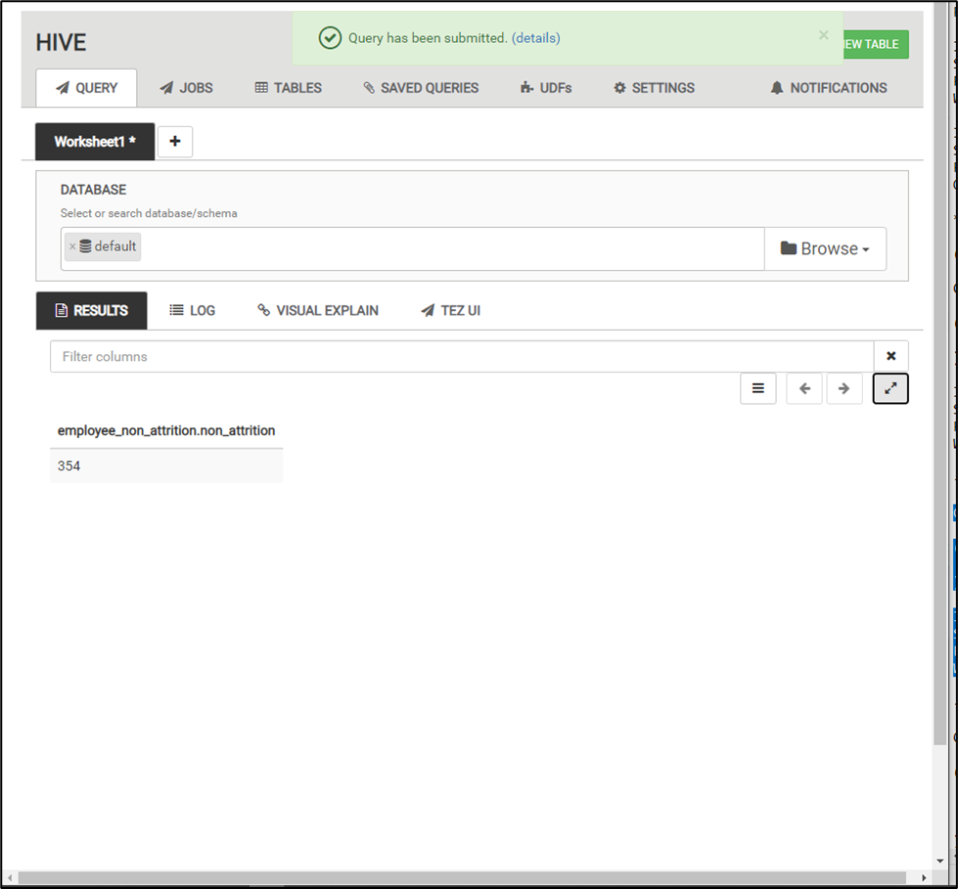

### Income Statistics for All Employees

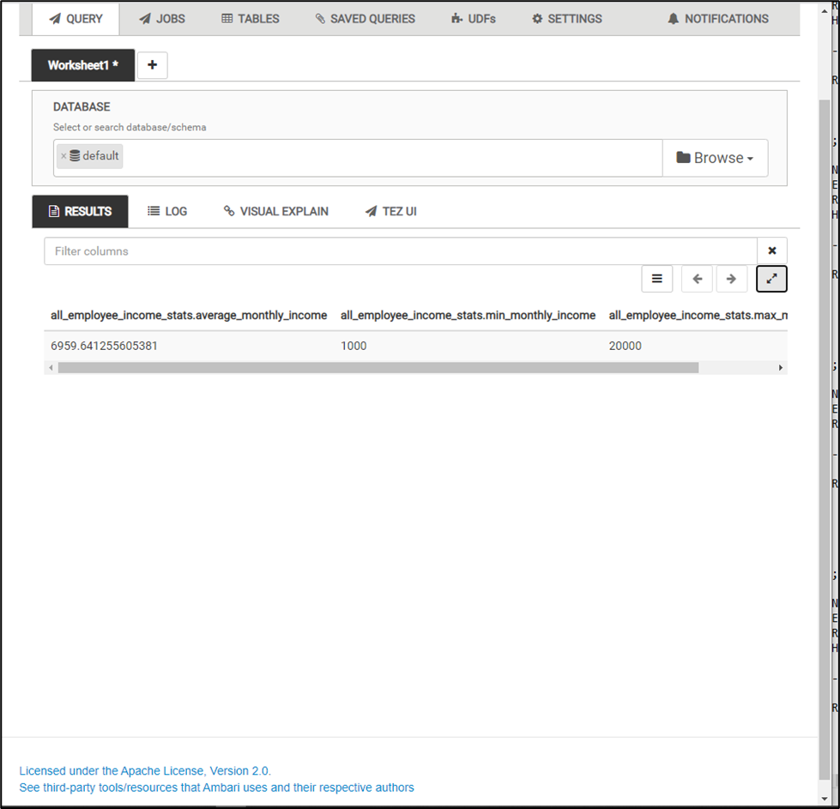

### Income Statistics for Employees with Attrition

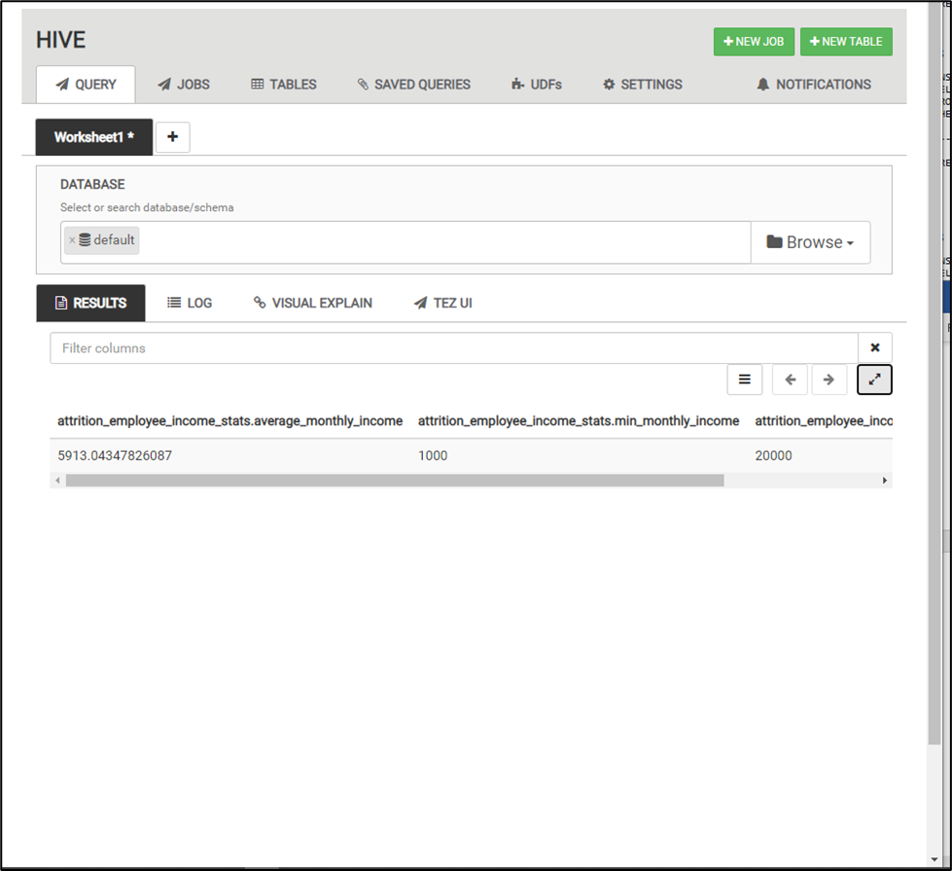

### Income Statistics for Employees without Attrition

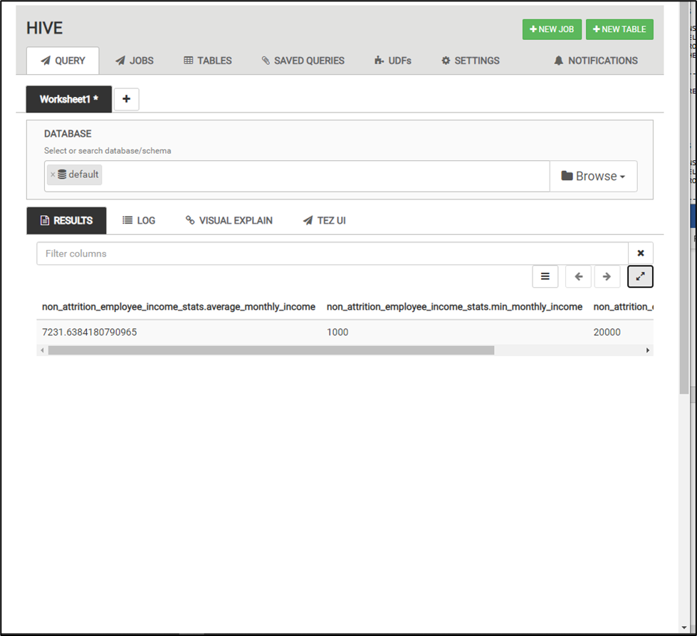

### Count by Monthly Income for Salespeople with Attrition

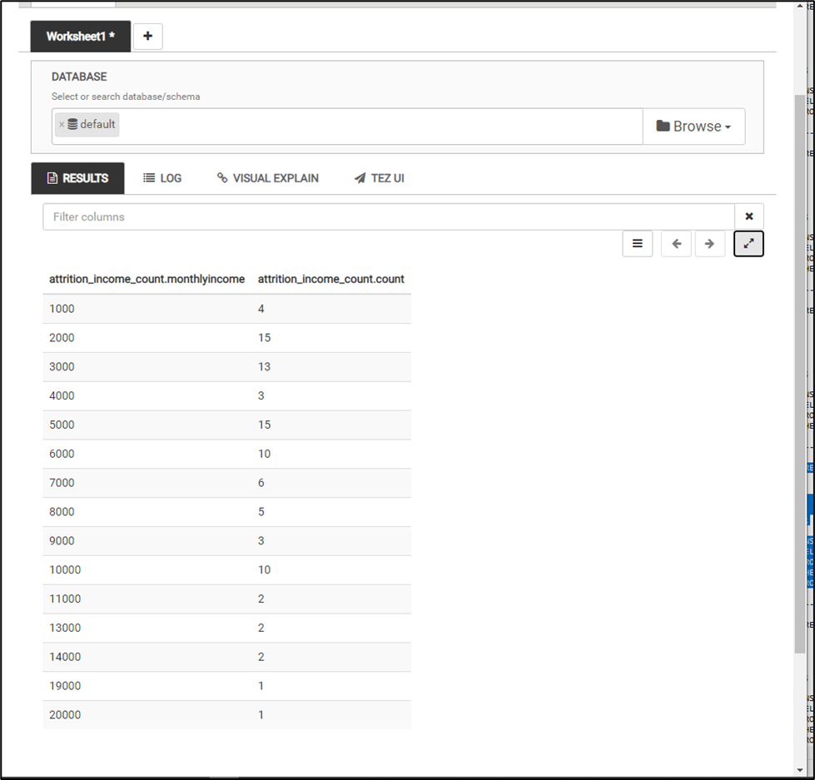

### Count by Monthly Income for Salespeople without Attrition

